THE WORD OF GOD

ANNOUNCEMENTS

Please stand as you are able.
THE OPENING ACCLAMATION
Celebrant Blessed be God: Father, Son, and Holy Spirit.
People And blessed be his kingdom, now and forever. Amen.

THE COLLECT FOR PURITY BCP p. 323

THE SUMMARY OF THE LAW BCP p. 324

GLORIA BCP p. 324
Glory be to God on high…

THE COLLECT OF THE DAY See insert

Please be seated.
THE HEBREW SCRIPTURES See insert

THE RESPONSE See insert

LETTERS TO THE CHURCHES See insert
Please stand as you are able.
THE HOLY GOSPEL See insert

THE SERMON The Rev. Dr. Amy Moehnke

THE NICENE CREED BCP, p. 326

THE PRAYERS OF THE PEOPLE BCP p. 328

CONFESSION OF SIN AND ABSOLUTION BCP p. 331
Most merciful God . . .

THE PEACE
Celebrant The peace of the Lord be always with you.
People And with thy spirit.

BLESSINGS
BIRTHDAY PRAYER BCP p. 830
O God, our times are in your hand: Look with favor, we pray, on your servants as they begin another year. Grant that they may grow in wisdom and grace, and strengthen their trust in your goodness all the days of their life; through Jesus Christ our Lord. Amen.


GUEST WELCOME & COMMUNION INSTRUCTIONS
When you’re ready to connect, scan the QR code to begin a text conversation with Mtr Amy. You may also complete the blue Connect Card, in the pew back in front of you, and drop in the collection plate.

All people are welcome at God’s table. You may drink from the chalice by guiding it to your lips, or you may intinct (dip) the consecrated host in the chalice, or simply consume the host. If you would like a gluten-free wafer, you may ask for one or point to your hand with one finger. If you would like to receive a blessing, please cross your arms over your chest. If you would like communion brought to you, please let an usher know.

THE HOLY COMMUNION

THE OFFERTORY
The people’s offerings are collected to support the ongoing work and ministry of our community.

Celebrant All things come of thee, O Lord.
People And of thine own have we given thee.
Please stand or kneel as you are able.

THE GREAT THANKSGIVING Eucharistic Prayer II, p. 340
Celebrant The Lord be with you.
People And with thy spirit.
Celebrant Lift up your hearts.
People We lift them up unto the Lord.
Celebrant Let us give thanks unto our Lord God.
People It is meet and right so to do.

The Celebrant continues BCP, p. 341
It is very meet, right, and our bounden duty…
…evermore praising thee, and saying,

THE SANCTUS
People Holy, holy, holy, Lord God of Hosts: Heaven and
earth are full of thy Glory. Glory be to thee, O
Lord Most High. Blessed is he that cometh in the name of the Lord. Hosanna in the highest.

The Celebrant continues BCP, p. 343
…By whom, and with whom, and in whom, in the unity of the Holy Ghost, all honor and glory be unto thee, O Father Almighty, world without end.
People AMEN.

Celebrant And now, as our Savior Christ hath taught us,
we are bold to say,
People Our Father, who art in heaven, hallowed be thy
Name, thy kingdom come, thy will be done, on
earth as it is in heaven. Give us this day our daily bread. And forgive us our trespasses, as we forgive those who trespass against us. And lead us not into temptation, but deliver us from evil. For thine is the kingdom, the power, and the glory, for ever and ever. Amen.

THE BREAKING AND SHARING OF THE BREAD & WINE
Celebrant Christ our Passover is sacrificed for us;
People Therefore let us keep the feast.

POST COMMUNION PRAYER BCP, p. 339
People Almighty and everliving God…

THE BLESSING

THE DISMISSAL
Celebrant Go in peace to love and serve the Lord.
People Thanks be to God.

The flowers on the altar are given in memory of:
Mitch Shelton

ANNOUNCEMENTS
Faith Art Journaling Workshop | Saturday, October 24 at 10:00 AM
Explore faith and creativity through art journaling in the Parish Hall! No experience needed; supplies provided. Bring a snack to share if you'd like.
RSVP: sebland56@outlook.com or call/text Shirley at 713-724-3528.

Blood Drive | Sunday, October 25
Give the gift of life! Help save lives by donating blood at Calvary. More details and sign-up information coming soon.
Bastrop Boo Bash | Saturday, October 31
Calvary will be on Main Street from **2:00–6:00 PM**, offering candy, water, and restroom access!
Volunteers Needed: 1:45–4:00 PM or 4:00–6:15 PM.
Costumes encouraged! Scan the QR code to sign up!
Stewardship Testimonials
-Makayla and Sochi Doughty
In February of 2026, our family started attending Calvary’s weekly 10 o’clock Sunday service. From the very first service we attended, people all around us greeted us, showed us around, and made us feel welcome. It was a comfortable environment where we felt like we could be ourselves. After about a month of attending, people told us about the Acolytes and how beautiful it would be to have a part in the service. At first, we were nervous and unsure, but with encouragement and advice from many wonderful people at Calvary, we reached out and were immediately welcomed in.
Being a part of Calvary has shown us so many opportunities to become involved in our church and community. Through serving as Acolytes, participating in Vacation Bible Camp, and simply getting to know the people around us, we have been able to meet so many new people and become a part of something bigger than ourselves. We are grateful for how welcoming Calvary has been to our family and for the opportunities it has given us to serve, grow, and build connections within our community.
-Makayla and Sochi Doughty



All Saints’ Day Remembrances
Honor and remember loved ones who have passed.
Scan the QR code to include their names in Calvary’s remembrances.
Plenty Good Room | 2027 Stewardship
Your generosity helps Calvary continue its mission of faith, love, and service. Every pledge makes a difference and helps us make room for all at God’s table.
Make Your Pledge Today. Scan the QR Code.
BHS Pathways Ministry | Support Local Students
Help provide food, clothing, and essentials to Bastrop High School students and families in need.
Donate Today, scan the QR Code!
CALVARY PRAYER LIST
For those celebrating  birthdays & anniversaries:  Jacque Avent  Carolyn Holt  Minifred Trigg  Sundown Hunter  Benjamin Gray  Curtis and Jamie McDonald  For those who have died:  Janet Spradlin  Mitch Shelton  William Volpe  Discernment & wisdom:  Sarah Mast  Ryan  Michael  Stephanie  Long-term care & homebound:  Frances Johnson  Mary Poirier  Joe & Dee Turnus  Deogracia C. Perez  Marty Moran  Jim Kershaw  Kay Wesson  Stu Brubaker  Serving in the military:  Major Will McMurrey  SGT Daulton Robinson  Army Company 82  PFC Morgan H. Robinson  CW4 William "Billy" Black  CJ Calhoun | Healing & strength:  Barbara Kayton  Buck Bland  Gabriela Tuttrup  Harrison Hocker  John & Barbara Allbright  Julie Hodge  Neil McCasland  Nancy Jensen-Case  Byron Rentfro  Cheryl Green  Roxanne Alley  Shirley Bland  Sandy Walthall  Carol Hanna  Carolyn Wigington  David Mosher  Elmer Richter  Rachel Richter  Mattias Bertelsen  Members of the Vestry  Kitty Howell  Nancy Jensen-Case  Mo Tanner  John Meyer  Terry Stringer  Kathy Gryta  LaDonne Love  Eddie Mendoza - Junior Warden  Kate Hurst - Senior Warden
CALVARY CLERGY AND STAFF
Locum Tenens | The Rev. Dr. Amy Moehnke  curate@cecbastrop.org
Director of Music | Dr. Justin West music@cecbastrop.org
Parish Administrator | Tracy Yeargin  office@cecbastrop.org
Lay Ministry Coordinator | Jamie McDonald jamie@cecbastrop.org
Bookkeeper | Alejandro Icazbalceta bookkeeper@cecbastrop.org

Communications Manager | Fernando Preciado communications@cecbastrop.org
Sexton | Rosa Gonzalez, Sexton  Sexton@cecbastrop.org

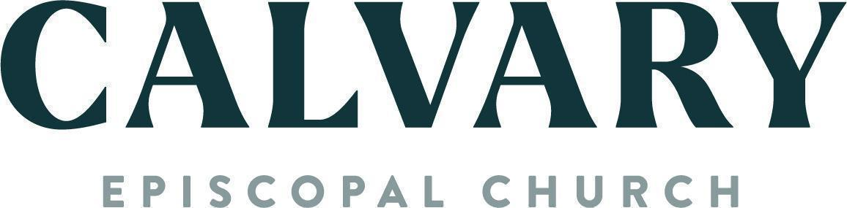
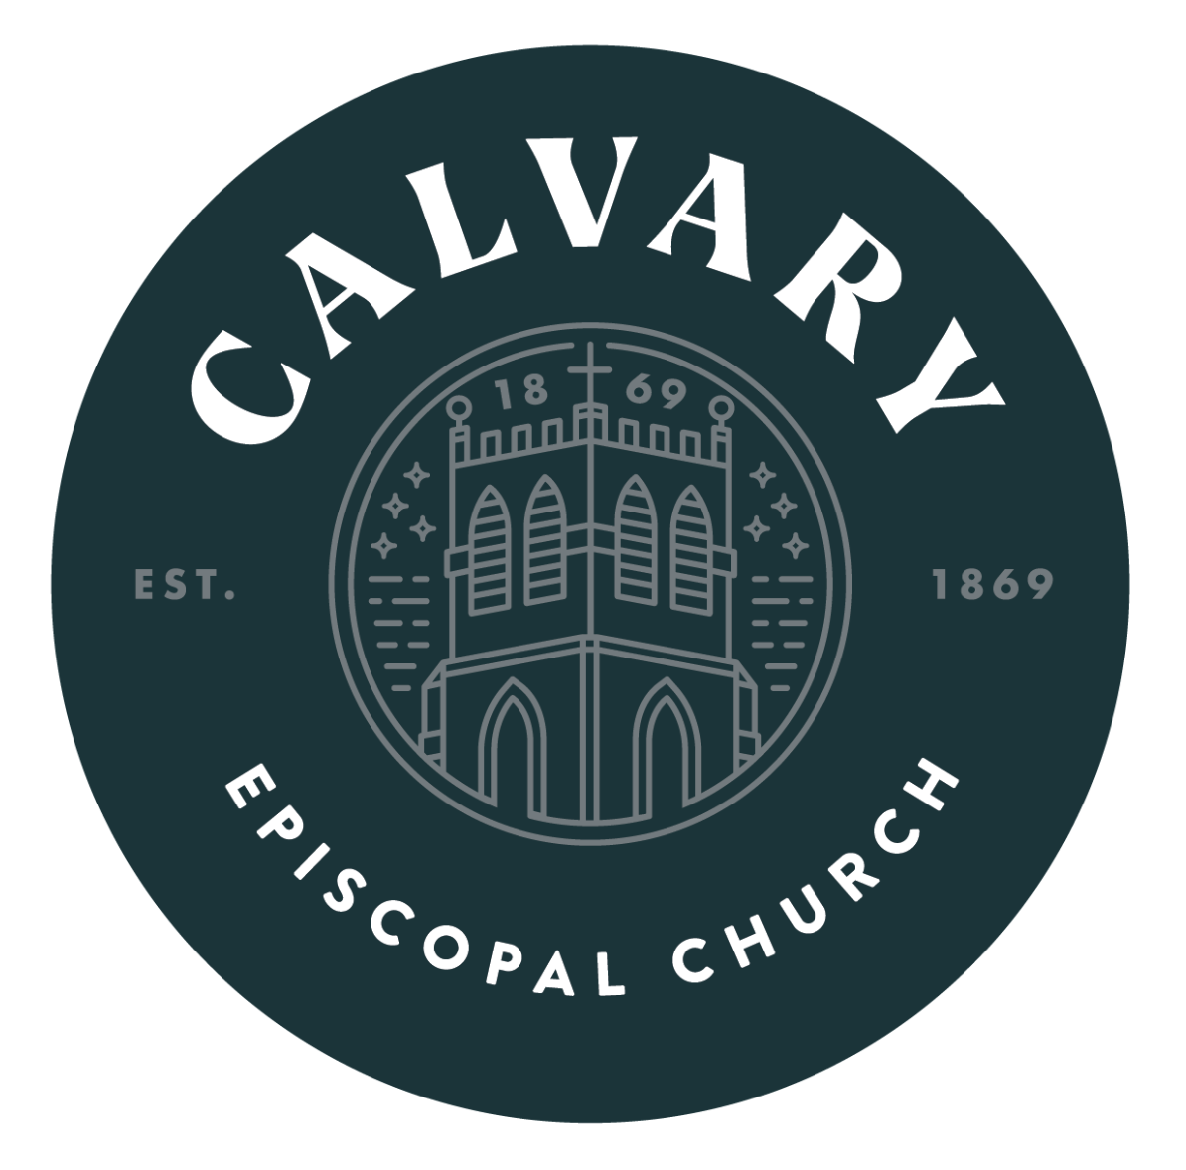

HOLY EUCHARIST, RITE 1
Twenty-First Sunday
after Pentecost
Oct 18, 2026 8:00 AM

603 SPRING ST. BASTROP, TX 78602
CECBASTROP.ORG ⎸ (512) 303-7515
WWW.FACEBOOK.COM/CECBASTROP

