We gather in worship and thanksgiving to offer our gratitude to God for all life’s blessings.
After the service, we invite you to Formation for All Ages in the Parish Hall. Restrooms are located in the Galilee Building behind the sanctuary. Children are always welcome in worship. For families who prefer it, a staffed nursery—with trained and certified caregivers—is available in the Galilee Building for children from birth to age 4.

WELCOME & ANNOUNCEMENTS
PRELUDE | Joyful, Joyful, We Adore Thee | Hayes

THE WORD OF GOD

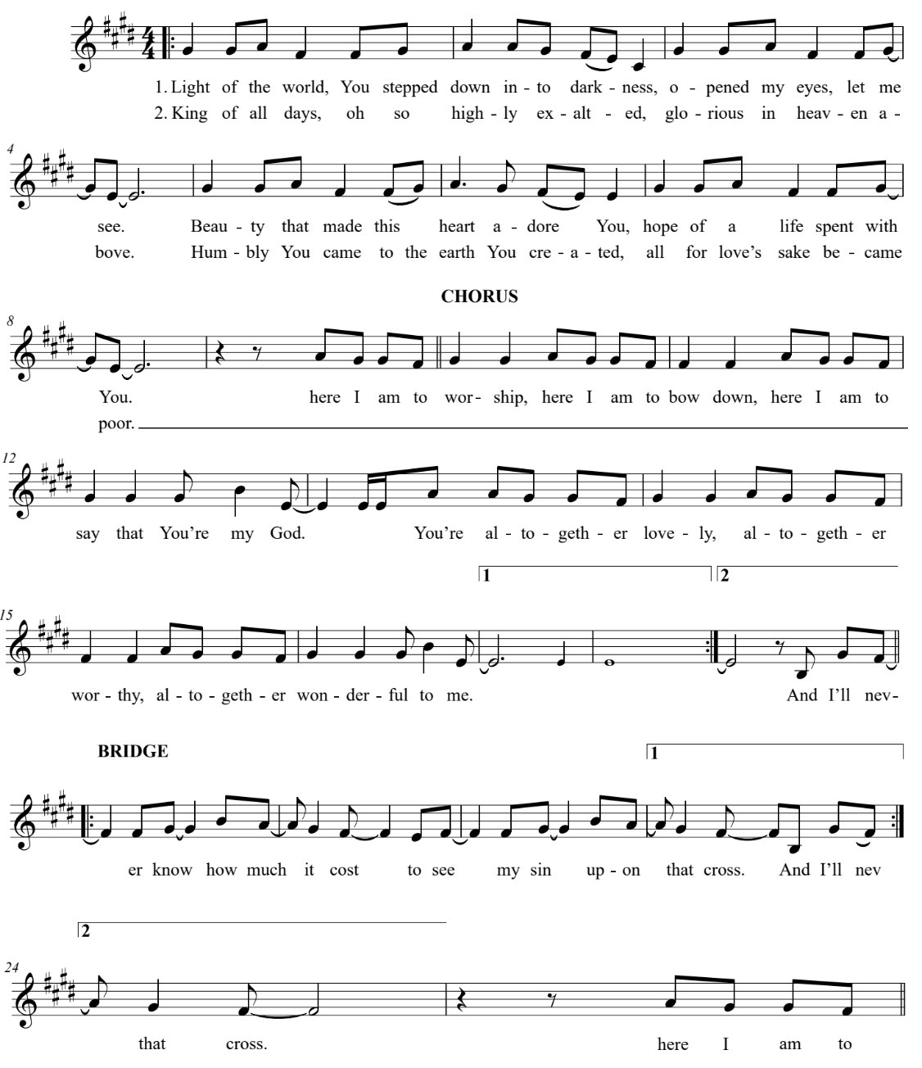
Please stand as you are able.
OPENING SONG | Here I Am to Worship

THE OPENING ACCLAMATION
Celebrant Blessed be God: Father, Son, and Holy Spirit.
People And blessed be God's kingdom, now and forever. Amen.
Celebrant
& People Almighty God, to you all hearts are open, all desires known, and from you
no secrets are hid: Cleanse the thoughts of our hearts by the inspiration of your Holy Spirit, that we may perfectly love you, and worthily magnify your holy Name; through Christ our Lord. Amen.

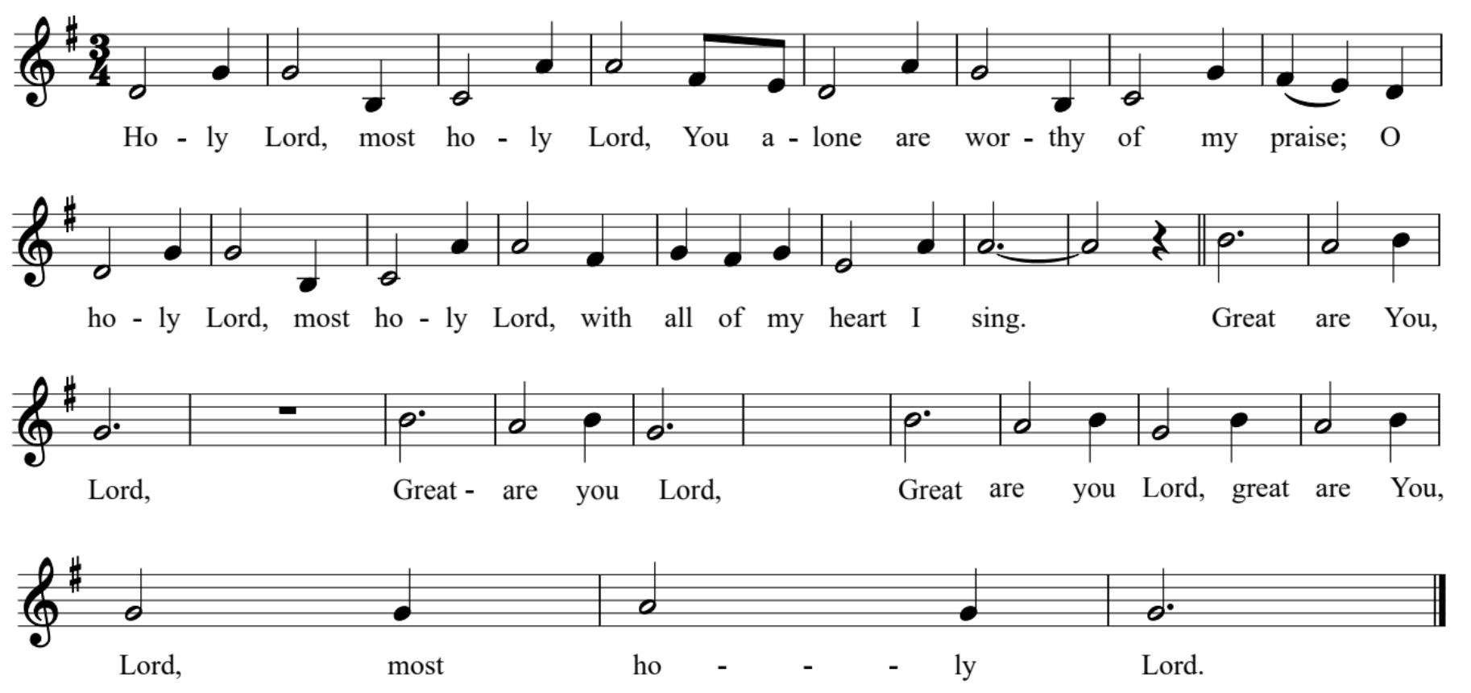  SONG OF PRAISE RENEW 69 | Great Are You, Lord

THE COLLECT OF THE DAY
Celebrant The Lord be with you.
People And also with you.
Celebrant Let us pray. Grant, O merciful God, that your Church, being gathered together in unity by
your Holy Spirit, may show forth your power among all peoples, to the glory of your
Name; through Jesus Christ our Lord, who lives and reigns with you and the Holy Spirit,
one God, for ever and ever. Amen.

Please be seated.
THE HEBREW SCRIPTURES Isaiah 51:1-6
A reading from the Book of the Prophet Isaiah.

Listen to me, you that pursue righteousness,
you that seek the Lord.

Look to the rock from which you were hewn,
and to the quarry from which you were dug.

Look to Abraham your father
and to Sarah who bore you;

for he was but one when I called him,
but I blessed him and made him many.

For the Lord will comfort Zion;
he will comfort all her waste places,

and will make her wilderness like Eden,
her desert like the garden of the Lord;

joy and gladness will be found in her,
thanksgiving and the voice of song.

Listen to me, my people,
and give heed to me, my nation;

for a teaching will go out from me,
and my justice for a light to the peoples.

I will bring near my deliverance swiftly,
my salvation has gone out
and my arms will rule the peoples;

the coastlands wait for me,
and for my arm they hope.

The reading continues on the next page…

Lift up your eyes to the heavens,
and look at the earth beneath;

for the heavens will vanish like smoke,
the earth will wear out like a garment,
and those who live on it will die like gnats;

but my salvation will be for ever,
and my deliverance will never be ended.

Reader The Word of the Lord.
People Thanks be to God.

THE PSALM Psalm 67
We will pray the psalm responsively by whole verse.

1 I will give thanks to you, O Lord, with my whole heart; *
before the gods I will sing your praise.

2 I will bow down toward your holy temple
and praise your Name, *
because of your love and faithfulness;

3 For you have glorified your Name *
and your word above all things.

4 When I called, you answered me; *
you increased my strength within me.

5 All the kings of the earth will praise you, O Lord, *
when they have heard the words of your mouth.

The Psalm continues on the next page…

6 They will sing of the ways of the Lord, *
that great is the glory of the Lord.

7 Though the Lord be high, he cares for the lowly; *
he perceives the haughty from afar.

8 Though I walk in the midst of trouble, you keep me safe; *
you stretch forth your hand against the fury of my enemies;
your right hand shall save me.

9 The Lord will make good his purpose for me; *
O Lord, your love endures for ever;
do not abandon the works of your hands.

LETTERS TO THE CHURCHES Romans 12:1-8
A reading from the Letter of Paul to the Romans.

I appeal to you therefore, brothers and sisters, by the mercies of God, to present your bodies as a living sacrifice, holy and acceptable to God, which is your spiritual worship. Do not be conformed to this world, but be transformed by the renewing of your minds, so that you may discern what is the will of God-- what is good and acceptable and perfect.

For by the grace given to me I say to everyone among you not to think of yourself more highly than you ought to think, but to think with sober judgment, each according to the measure of faith that God has assigned. For as in one body we have many members, and not all the members have the same function, so we, who are many, are one body in Christ, and individually we are members one of another. We have gifts that differ according to the grace given to us: prophecy, in proportion to faith; ministry, in ministering; the teacher, in teaching; the exhorter, in exhortation; the giver, in generosity; the leader, in diligence; the compassionate, in cheerfulness.

Reader The Word of the Lord.
People Thanks be to God.

Please stand as you are able.
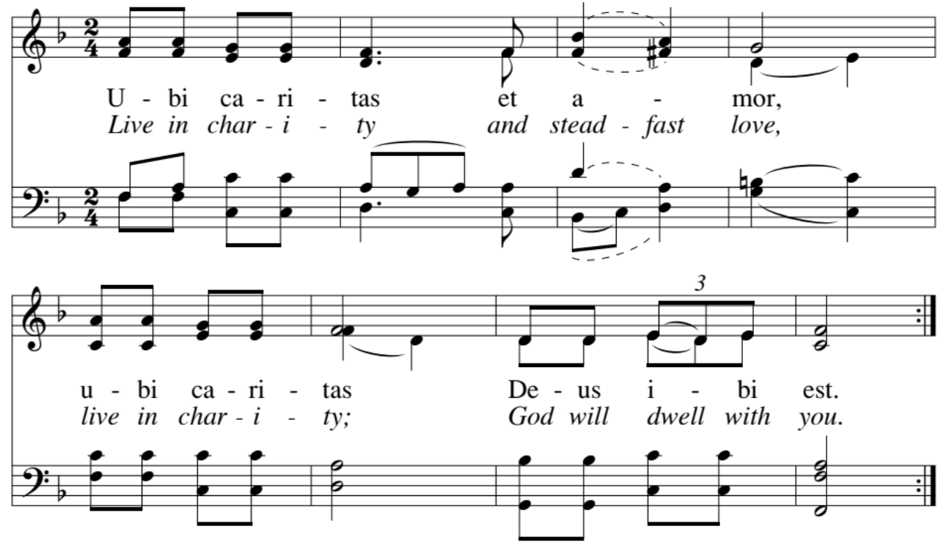  GRADUAL SONG | Ubi Caritas/Live in Charity

THE GOSPEL Matthew 16:13-20
Gospeller The Holy Gospel of our Lord Jesus Christ according to Matthew.
People Glory to you, Lord Christ.

When Jesus came into the district of Caesarea Philippi, he asked his disciples, “Who do people say that the Son of Man is?” And they said, “Some say John the Baptist, but others Elijah, and still others Jeremiah or one of the prophets.” He said to them, “But who do you say that I am?” Simon Peter answered, “You are the Messiah, the Son of the living God.” And Jesus answered him, “Blessed are you, Simon son of Jonah! For flesh and blood has not revealed this to you, but my Father in heaven. And I tell you, you are Peter, and on this rock I will build my church, and the gates of Hades will not prevail against it. I will give you the keys of the kingdom of heaven, and whatever you bind on earth will be bound in heaven, and whatever you loose on earth will be loosed in heaven.” Then he sternly ordered the disciples not to tell anyone that he was the Messiah.

Gospeller The Gospel of the Lord.
People Praise to you, Lord Christ.

THE SERMON The Rev. Dr Amy Moehnke

Please stand as you are able.
THE NICENE CREED BCP, p. 358
People We believe in one God, the Father, the Almighty, maker of heaven and earth, of all that is, seen and unseen.

We believe in one Lord, Jesus Christ, the only Son of God, eternally begotten of the Father, God from God, Light from Light, true God from true God, begotten, not made, of one Being with the Father. Through him all things were made. For us and for our salvation he came down from heaven: by the power of the Holy Spirit he became incarnate from the Virgin Mary, and was made man. For our sake he was crucified under Pontius Pilate; he suffered death and was buried.

On the third day he rose again in accordance with the Scriptures; he ascended into heaven and is seated at the right hand of the Father. He will come again in glory to judge the living and the dead, and his kingdom will have no end.

We believe in the Holy Spirit, the Lord, the giver of life, who proceeds from the Father and the Son. With the Father and the Son he is worshiped and glorified. He has spoken through the Prophets. We believe in one holy catholic and apostolic Church. We acknowledge one baptism for the forgiveness of sins. We look for the resurrection of the dead, and the life of the world to come. Amen.

THE PRAYERS OF THE PEOPLE Hear Our Prayer p. 77
Celebrant Heavenly Father, through Christ, you came into the world to be truth and life to all who
know you. Give us the insight to claim your kingship in our lives and to proclaim this
truth to the world as we pray Lord in your mercy, hear our prayer.
People Lord in your mercy, hear our prayer.
Intercessor We pray for the church, for those who lead worship, for those who pray, for those who
prophesy, for those who teach, and for those who serve the world in your name. That
together, we might fulfill your mission.
People Lord in your mercy, hear our prayer.
Intercessor We pray for this nation; for all in authority and for those who strive to better the lives of
all people in our country, that it might be a place of promise and possibility.
People Lord in your mercy, hear our prayer.
The prayer continues on the next page…
Intercessor We pray for the welfare of the world; for those who are persecuted and cry for justice;
for those who hunger and thirst for knowledge and freedom; for those who work for the
common good. That we may know peace and justice in all the world.
People Lord in your mercy, hear our prayer.
Intercessor We pray for the needs of our communities, for the hopes of families and for the needs of
each of us gathered here. That we might live abundantly.
People Lord in your mercy, hear our prayer.
Intercessor We pray for those who suffer, for their relief and comfort and we pray for all who are in
need. Asking also that we may be a part of this healing in meaningful ways. Especially
we pray for…
People Lord in your mercy, hear our prayer.
Intercessor We pray for the dying and the deceased, that all may find a loving home in the kingdom
promised to us through our savior. We pray also for those who mourn, that they may be
comforted now, in their time of need.
People Lord in your mercy, hear our prayer.
Celebrant We offer all these prayers and praises to you O God and ask that they may be granted as
may be best for us and for the world. In the name of the Father, Son, and Holy Spirit.
People Amen.

CONFESSION OF SIN & ABSOLUTION BCP, p. 352
Celebrant Let us confess our sins against God and our neighbor.

People Most merciful God, we confess that we have sinned against you in thought, word,
and deed, by what we have done, and by what we have left undone. We have not
loved you with our whole heart; we have not loved our neighbors as ourselves.
We are truly sorry and we humbly repent. For the sake of your Son Jesus Christ,
have mercy on us and forgive us; that we may delight in your will, and walk in your ways, to the glory of your Name. Amen.

Celebrant Almighty God have mercy on you, forgive you all your sins through our Lord Jesus
Christ, strengthen you in all goodness, and by the power of the Holy Spirit keep you in
eternal life. Amen.

THE PEACE
Celebrant The peace of the Lord be always with you.
People And also with you.

BIRTHDAY & ANNIVERSARY BLESSINGS
BIRTHDAY PRAYER BCP p. 830
O God, our times are in your hand: Look with favor, we pray, on your servants as they begin another year. Grant that they may grow in wisdom and grace, and strengthen their trust in your goodness all the days of their life; through Jesus Christ our Lord. Amen.


GUEST WELCOME & COMMUNION INSTRUCTIONS
When you’re ready to connect, scan the QR code to begin a text conversation with Mtr Amy. You may also complete the blue Connect Card, in the pew back in front of you, and drop in the collection plate.

All people are welcome at God’s table. You may drink from the chalice by guiding it to your lips, or you may intinct (dip) the consecrated host in the chalice, or simply consume the host. If you would like a gluten-free wafer, you may ask for one or point to your hand with one finger. If you would like to receive a blessing, please cross your arms over your chest. If you would like communion brought to you, please let an usher know.

THE HOLY COMMUNION


THE OFFERTORY
The people’s offerings are collected to support the ongoing work and ministry of our community. To give electronically, please use the QR code.

OFFERTORY HYMN 525 | The Church's One Foundation (vs. 1, 2, 4, 5)

Please stand as you are able.
THE DOXOLOGY 380, VS. 3
Praise God, from whom all blessings flow;
Praise Him, all creatures here below;
Praise Him above, ye heavenly host;
Praise Father, Son, and Holy Ghost.
Amen.

THE HOLY EUCHARIST Eucharistic Prayer B, BCP p. 367
Celebrant The Lord be with you.
People And also with you.
Celebrant Lift up your hearts.
People We lift them to the Lord.
Celebrant Let us give thanks to the Lord our God.
People It is right to give God thanks and praise.

The Celebrant continues
It is right, and a good and joyful thing, always and everywhere to give thanks to you, Father Almighty, Creator of heaven and earth…
…Therefore we praise you, joining our voices with Angels and Archangels and with all the company of heaven, who for ever sing this hymn to proclaim the glory of your Name:

THE SANCTUS S-127 Hampton

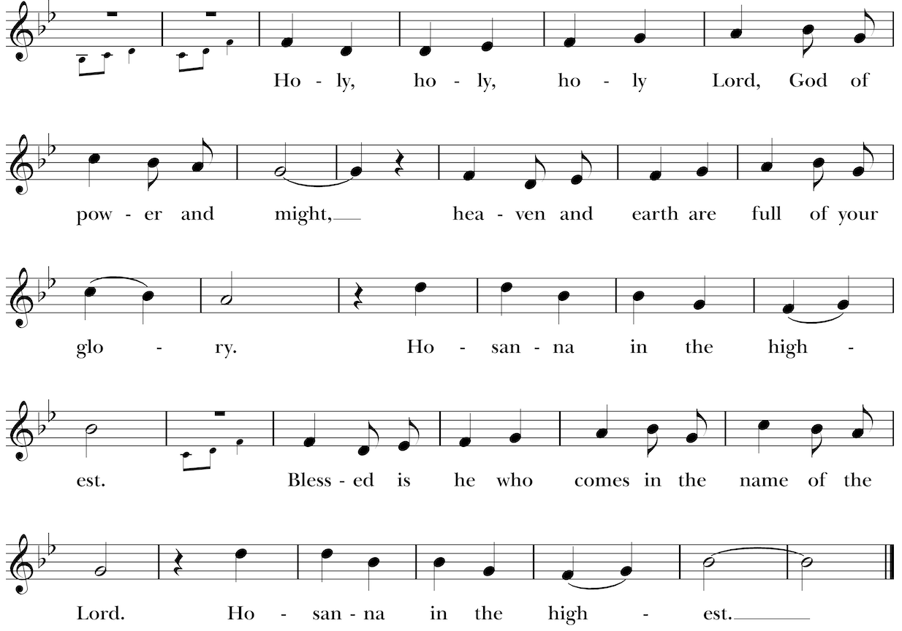
The people stand or kneel. The Celebrant continues
We give thanks to you, O God, for the goodness and love which you have made known to us in creation; in the calling of Israel to be your people; in your Word spoken through the prophets; and above all in the Word made flesh, Jesus, your Son. For in these last days you sent him to be incarnate from the Virgin Mary, to be the Savior and Redeemer of the world. In him, you have delivered us from evil, and made us worthy to stand before you. In him, you have brought us out of error into truth, out of sin into righteousness, out of death into life.
On the night before he died for us, our Lord Jesus Christ took bread; and when he had given thanks to you, he broke it, and gave it to his disciples, and said, “Take, eat: This is my Body, which is given for you. Do this for the remembrance of me.”
After supper he took the cup of wine; and when he had given thanks, he gave it to them, and said, “Drink this, all of you: This is my Blood of the new Covenant, which is shed for you and for many for the forgiveness of sins. Whenever you drink it, do this for the remembrance of me.”

Therefore, according to his command, O Father,
We remember his death,
We proclaim his resurrection,
We await his coming in glory;
And we offer our sacrifice of praise and thanksgiving to you, O Lord of all; presenting to you, from your creation, this bread and this wine. We pray you, gracious God, to send your Holy Spirit upon these gifts that they may be the Sacrament of the Body of Christ and his Blood of the new Covenant. Unite us to your Son in his sacrifice, that we may be acceptable through him, being sanctified by the Holy Spirit. In the fullness of time, put all things in subjection under your Christ, and bring us to that heavenly country where, with all your saints, we may enter the everlasting heritage of your children; through Jesus Christ our Lord, the firstborn of all creation, the head of the Church, and the author of our salvation.
By him, and with him, and in him, in the unity of the Holy Spirit all honor and glory is yours, Almighty Father, now and for ever.
THE GREAT AMEN

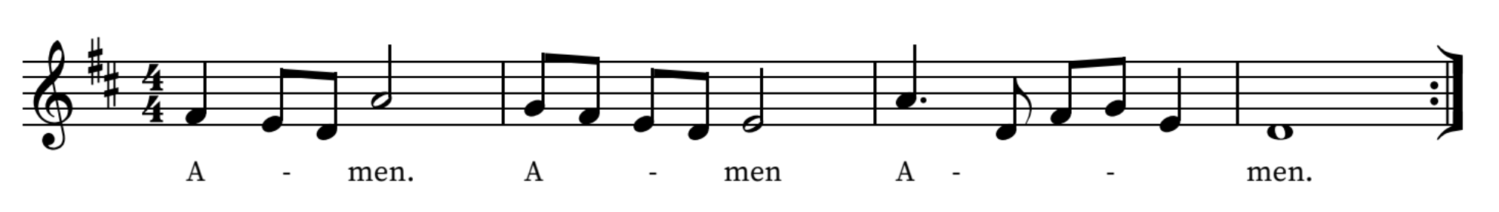

Celebrant And now, as our Savior Christ has taught us and in the language of our hearts, we are bold
to say
People
Our Father, who art in heaven,
hallowed be thy Name,
thy kingdom come,
thy will be done,
on earth as it is in heaven.
Give us this day our daily bread.
And forgive us our trespasses,
as we forgive those who trespass against us.
And lead us not into temptation,
but deliver us from evil.
For thine is the kingdom, and the power, and the glory,
for ever and ever. Amen.

Padre nuestro que estás en el cielo,
santificado sea tu nombre;
venga tu reino;
hágase tu voluntad
en la tierra como en el cielo.
Danos hoy nuestro pan de cada día.
Perdona nuestras ofensas,
como también nosotros perdonamos
a los que nos ofenden.
No nos dejes caer en la tentación
y líbranos del mal.
Porque tuyo es el reino, el poder
y la gloria,
ahora y por siempre. Amén.

THE BREAKING AND SHARING OF THE BREAD & WINE

Celebrant Alleluia. Christ our Passover is sacrificed for us;
People Therefore let us keep the feast. Alleluia.
FRACTION ANTHEM | O Bread of Life
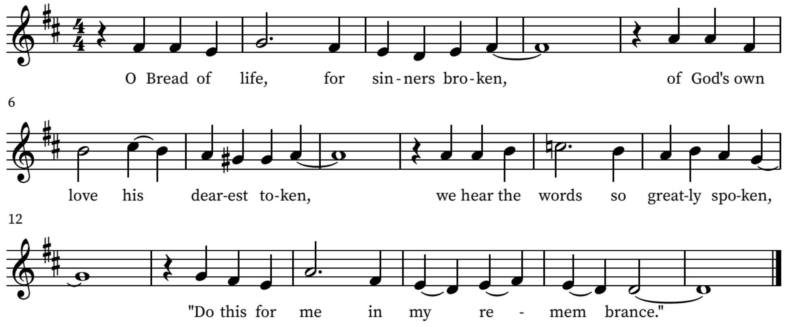
THE INVITATION
Celebrant The Gifts of God for the People of God. Take them in remembrance that Christ
died for you, and feed on him in your hearts by faith, with thanksgiving.

All people are welcome at God’s table. You may drink from the chalice by guiding it to your lips or you may instinct (dip) the consecrated host in the chalice or simply consume the host. If you would like a gluten-free wafer you may ask for one or point to your hand with one finger. If you would like to receive a blessing, please cross your arms over your chest. If you would like communion brought to you, please let an usher know.

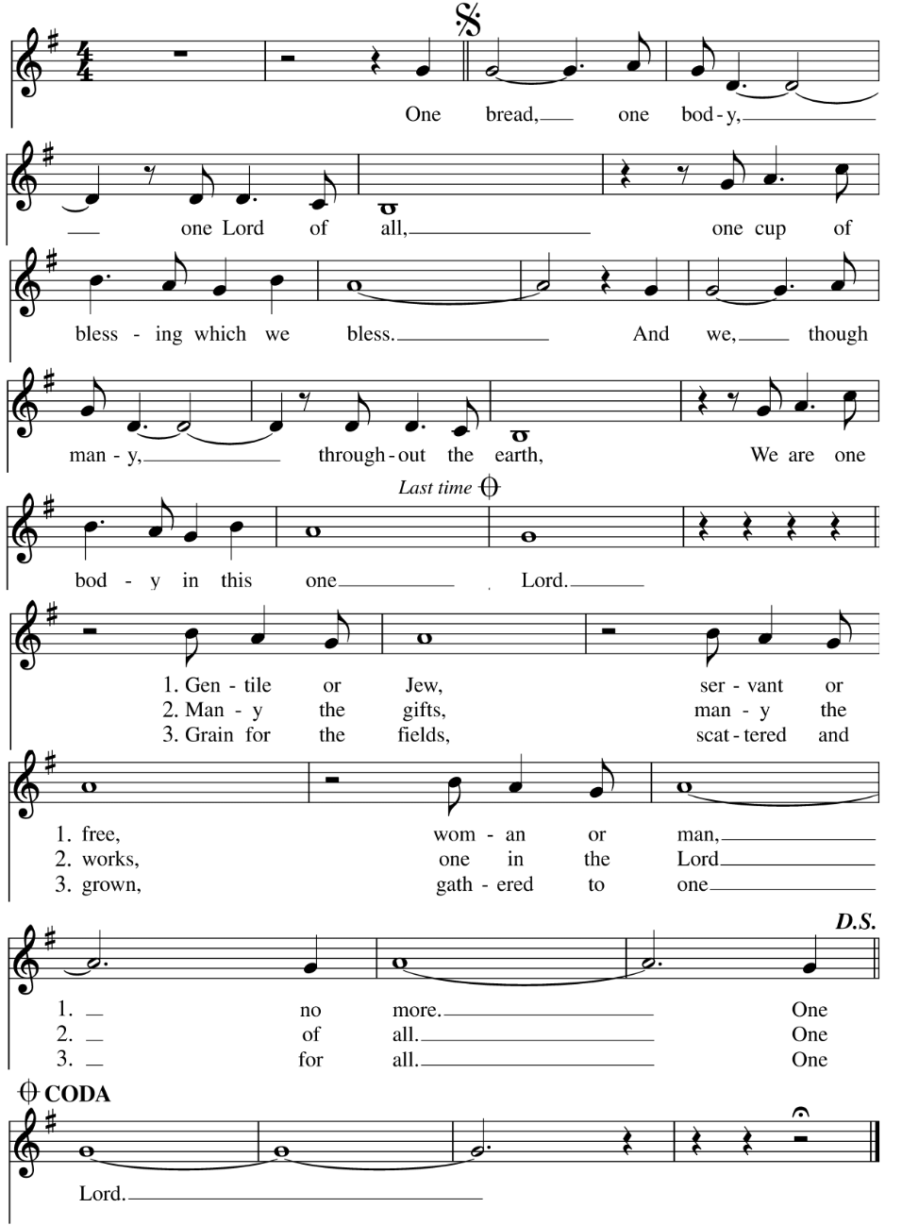  COMMUNION HYMN LEVAS 151 | One Bread, One Body

COMMUNION HYMN 513 | Like the Murmur of the Dove's Song

Please stand as you are able.
POST COMMUNION PRAYER BCP, p. 366
Celebrant
and people Almighty and everliving God, we thank you for feeding us with the
spiritual food of the most precious Body and Blood of your Son our Savior
Jesus Christ; and for assuring us in these holy mysteries that we are living
members of the Body of your Son, and heirs of your eternal kingdom. And
now, Father, send us out to do the work you have given us to do, to love
and serve you as faithful witnesses of Christ our Lord. To him, to you, and
to the Holy Spirit, be honor and glory, now and for ever. Amen.

THE BLESSING

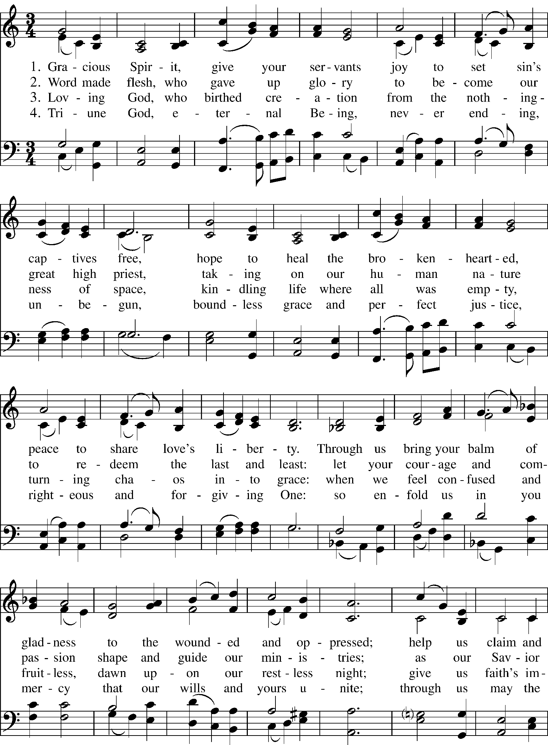  CLOSING HYMN WLP 782 | Gracious Spirit, Give Your Servants

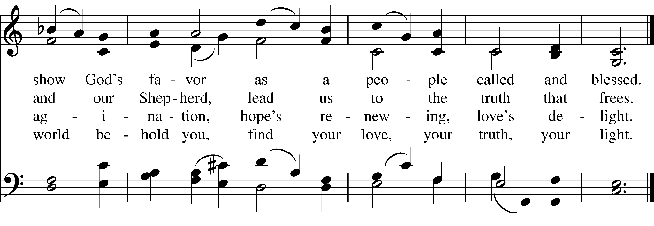

THE DISMISSAL
Celebrant Go in peace to love and serve the Lord.
People Thanks be to God.

POSTLUDE

All rights reserved. Today’s music licensed under One License #A-731928 & CCLI License #1506679.

CALVARY PRAYER LIST

For those who have died:  Mike Moran  Long-term care & homebound:  Frances Johnson  Mary Poirier  Joe & Dee Turnus  Deogracia C. Perez  Marty Moran  Jim Kershaw  Discernment & wisdom:  Diane Weir  Simone Gregoire  Jeff Little  Sarah Mast  Rector Search Committee Members  Randy Fritz  Barbara Kayton  Sandy Kibby  Tom Palaima  Erika Rankin  Brianna Reyna  LaDonna Love - Vestry Rep  Terry Stringer - Vestry Rep  Kate Hurst - Sr. Warden | For those celebrating  birthdays & anniversaries:  Rosa Gonzalez  Debbie Higgins  Susie Tucker  Madelaine & Tom Seay  Mary & Pat Robson  Serving in the military:  Major Will McMurrey  AFC Tiernan O’Rourke  SGT Daulton Robinson  Army Company 82  PFC Morgan H. Robinson  CW4 William "Billy" Black  CJ Calhoun | Healing & strength:  Ann Lunday  Barbara Kayton  Buck Bland  Gabriela Tuttrup  Harrison Hocker  John & Barbara Allbright  Julie Hodge  Neil McCasland  Kay Wesson  Ben Everett  Nancy Jensen-Case  Byron Rentfro  Cheryl Green  Roxanne Alley  Shirley Bland  Chris Trejo  Roland Nava  Mitch Shelton  Mona Yeargin  Bessie Hurst

COMING UP AT CALVARY

Formation for All Ages | Starts Today: Sunday, August 23
Formation for All Ages begins today immediately following the 10:00 AM service. All are invited to stay, connect, and grow in faith together.
Hungry Elders | Wednesday, September 2
Hungry Elders will gather on Wednesday, September 2, for lunch, fellowship, and community. Older Calvary parishioners are invited to come enjoy time together and connect with others in the congregation.

Upcoming Baptism Date | Sunday, September 13
Baptism is a public declaration of faith and a celebration of new life in Christ. Our next baptism date will be Sunday, September 13, the Feast of the Holy Cross. If you have questions or are interested in baptism, please contact Mother Amy at curate@cecbastrop.org.
Calvary Art Fest | September 18–20 | ART STILL NEEDED!
Calvary Art Fest is coming soon, and artists are still invited to submit their work. Please consider sharing your art and helping make this year’s festival a beautiful celebration of creativity, community, and faith.
SCAN QR CODE FOR MORE INFO


Altar Flowers Giving
Let beauty become prayer. Honor a loved one or offer thanksgiving through flowers placed on the altar. Dedications may be included.
Scan the QR code to participate.

