We gather in worship and thanksgiving to offer our gratitude to God for all life’s blessings.
After the service, we invite you to continue the morning with coffee and conversation in the Parish Hall. Restrooms are located in the Galilee Building behind the sanctuary. Children are always welcome in worship. For families who prefer it, a staffed nursery—with trained and certified caregivers—is available in the Galilee Building for children from birth to age 4.

WELCOME & ANNOUNCEMENTS
PRELUDE | There Shall Be Showers of Blessing | Smith

THE WORD OF GOD

Please stand as you are able.
OPENING HYMN 594 | God of Grace and God of Glory

THE OPENING ACCLAMATION
Celebrant Blessed be God: Father, Son, and Holy Spirit.
People And blessed be God's kingdom, now and forever. Amen.
Celebrant
& People Almighty God, to you all hearts are open, all desires known, and from you
no secrets are hid: Cleanse the thoughts of our hearts by the inspiration of your Holy Spirit, that we may perfectly love you, and worthily magnify your holy Name; through Christ our Lord. Amen.

S 280
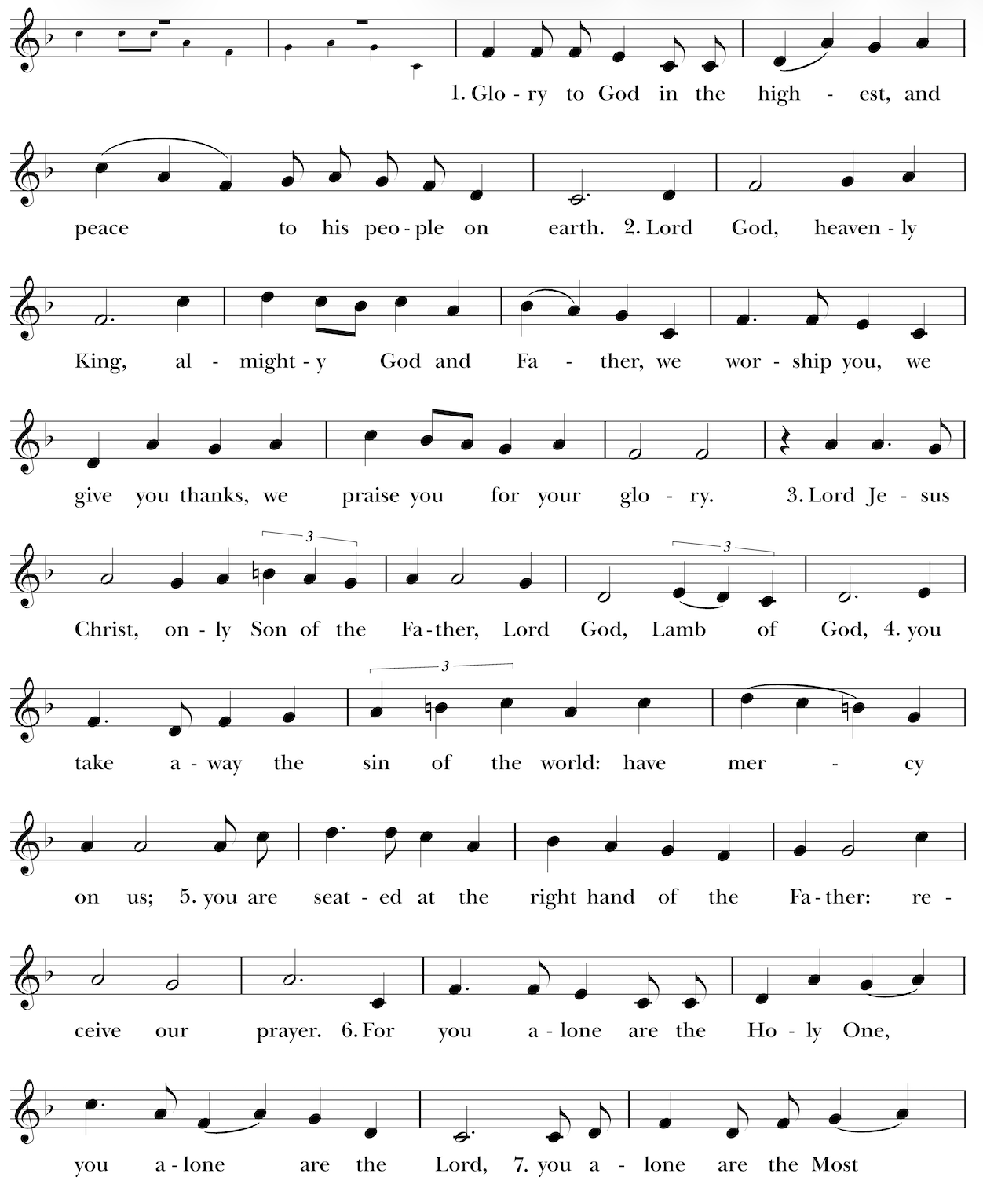

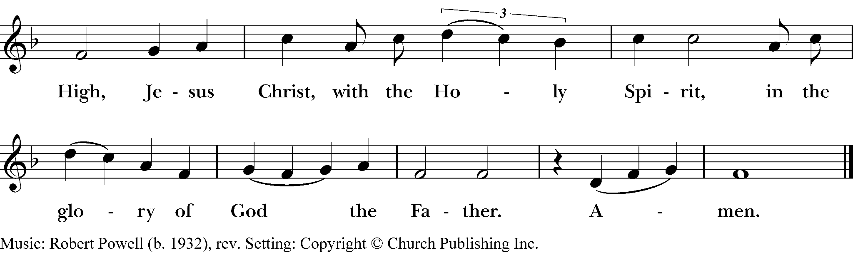
THE COLLECT OF THE DAY
Celebrant The Lord be with you.
People And also with you.
Celebrant Let us pray. O God, the protector of all who trust in you, without whom nothing is
strong, nothing is holy: Increase and multiply upon us your mercy; that, with you as our
ruler and guide, we may so pass through things temporal, that we lose not the things
eternal; through Jesus Christ our Lord, who lives and reigns with you and the Holy
Spirit, one God, for ever and ever. Amen.

Please be seated.
THE HEBREW SCRIPTURES I Kings 3:5-12
A reading from the First Book of Kings.

At Gibeon the Lord appeared to Solomon in a dream by night; and God said, “Ask what I should give you.” And Solomon said, “You have shown great and steadfast love to your servant my father David, because he walked before you in faithfulness, in righteousness, and in uprightness of heart toward you; and you have kept for him this great and steadfast love, and have given him a son to sit on his throne today. And now, O Lord my God, you have made your servant king in place of my father David, although I am only a little child; I do not know how to go out or come in. And your servant is in the midst of the people whom you have chosen, a great people, so numerous they cannot be numbered or counted. Give your servant therefore an understanding mind to govern your people, able to discern between good and evil; for who can govern this your great people?”

It pleased the Lord that Solomon had asked this. God said to him, “Because you have asked this, and have not asked for yourself long life or riches, or for the life of your enemies, but have asked for yourself understanding to discern what is right, I now do according to your word. Indeed I give you a wise and discerning mind; no one like you has been before you and no one like you shall arise after you.”

Reader The Word of the Lord.
People Thanks be to God.

THE PSALM Psalm 119:129-136
We will pray the psalm responsively by whole verse.

129 Your decrees are wonderful; *
therefore I obey them with all my heart.

130 When your word goes forth it gives light; *
it gives understanding to the simple.

131 I open my mouth and pant; *
I long for your commandments.

132 Turn to me in mercy, *
as you always do to those who love your Name.

133 Steady my footsteps in your word; *
let no iniquity have dominion over me.

134 Rescue me from those who oppress me, *
and I will keep your commandments.

135 Let your countenance shine upon your servant *
and teach me your statutes.

136 My eyes shed streams of tears, *
because people do not keep your law.

LETTERS TO THE CHURCHES Romans 8:26-39
A reading from the Letter of Paul to the Romans.

The Spirit helps us in our weakness; for we do not know how to pray as we ought, but that very Spirit intercedes with sighs too deep for words. And God, who searches the heart, knows what is the mind of the Spirit, because the Spirit intercedes for the saints according to the will of God.

We know that all things work together for good for those who love God, who are called according to his purpose. For those whom he foreknew he also predestined to be conformed to the image of his Son, in order that he might be the firstborn within a large family. And those whom he predestined he also called; and those whom he called he also justified; and those whom he justified he also glorified.

What then are we to say about these things? If God is for us, who is against us? He who did not withhold his own Son, but gave him up for all of us, will he not with him also give us everything else? Who will bring any charge against God's elect? It is God who justifies. Who is to condemn? It is Christ Jesus, who died, yes, who was raised, who is at the right hand of God, who indeed intercedes for us. Who will separate us from the love of Christ? Will hardship, or distress, or persecution, or famine, or nakedness, or peril, or sword? As it is written,

“For your sake we are being killed all day long;
we are accounted as sheep to be slaughtered.”

No, in all these things we are more than conquerors through him who loved us. For I am convinced that neither death, nor life, nor angels, nor rulers, nor things present, nor things to come, nor powers, nor height, nor depth, nor anything else in all creation, will be able to separate us from the love of God in Christ Jesus our Lord.

Reader The Word of the Lord.
People Thanks be to God.

Please stand as you are able.
GRADUAL HYMN 447 | The Christ Who Died But Rose Again (vs. 2, 3, 4)
THE GOSPEL Matthew 13:31-33, 44-52
Gospeller The Holy Gospel of our Lord Jesus Christ according to Matthew.
People Glory to you, Lord Christ.

Jesus put before the crowds another parable: “The kingdom of heaven is like a mustard seed that someone took and sowed in his field; it is the smallest of all the seeds, but when it has grown it is the greatest of shrubs and becomes a tree, so that the birds of the air come and make nests in its branches.”

The reading continues on the next page…
He told them another parable: “The kingdom of heaven is like yeast that a woman took and mixed in with three measures of flour until all of it was leavened.”

“The kingdom of heaven is like treasure hidden in a field, which someone found and hid; then in his joy he goes and sells all that he has and buys that field.

“Again, the kingdom of heaven is like a merchant in search of fine pearls; on finding one pearl of great value, he went and sold all that he had and bought it.

“Again, the kingdom of heaven is like a net that was thrown into the sea and caught fish of every kind; when it was full, they drew it ashore, sat down, and put the good into baskets but threw out the bad. So it will be at the end of the age. The angels will come out and separate the evil from the righteous and throw them into the furnace of fire, where there will be weeping and gnashing of teeth.

“Have you understood all this?” They answered, “Yes.” And he said to them, “Therefore every scribe who has been trained for the kingdom of heaven is like the master of a household who brings out of his treasure what is new and what is old.”

Gospeller The Gospel of the Lord.
People Praise to you, Lord Christ.

THE SERMON The Rev. Dr Amy Moehnke

Please stand as you are able.
THE NICENE CREED BCP, p. 358
People We believe in one God, the Father, the Almighty, maker of heaven and earth, of all that is, seen and unseen.

We believe in one Lord, Jesus Christ, the only Son of God, eternally begotten of the Father, God from God, Light from Light, true God from true God, begotten, not made, of one Being with the Father. Through him all things were made. For us and for our salvation he came down from heaven: by the power of the Holy Spirit he became incarnate from the Virgin Mary, and was made man. For our sake he was crucified under Pontius Pilate; he suffered death and was buried.
On the third day he rose again in accordance with the Scriptures; he ascended into heaven and is seated at the right hand of the Father. He will come again in glory to judge the living and the dead, and his kingdom will have no end.

We believe in the Holy Spirit, the Lord, the giver of life, who proceeds from the Father and the Son. With the Father and the Son he is worshiped and glorified. He has spoken through the Prophets. We believe in one holy catholic and apostolic Church. We acknowledge one baptism for the forgiveness of sins. We look for the resurrection of the dead, and the life of the world to come. Amen.

THE PRAYERS OF THE PEOPLE Form III, BCP pg. 387

Celebrant Father, we pray for your holy Catholic Church;
People That we all may be one.

Intercessor Grant that every member of the Church may truly and humbly serve you;
People That your Name may be glorified by all people.

Intercessor We pray for all bishops, priests, and deacons;
People That they may be faithful ministers of your Word and Sacraments.

Intercessor We pray for all who govern and hold authority in the nations of the world;
People That there may be justice and peace on the earth.

Intercessor Give us grace to do your will in all that we undertake;
People That our works may find favor in your sight.

Intercessor Have compassion on those who suffer from any grief or trouble;
People That they may be delivered from their distress.

Intercessor Give to the departed eternal rest;
People Let light perpetual shine upon them.

Intercessor We praise you for your saints who have entered into joy;
People May we also come to share in your heavenly kingdom.

Intercessor Let us pray for our own needs and those of others.

The Celebrant will add a concluding Collect.

CONFESSION OF SIN & ABSOLUTION BCP, p. 352
Celebrant Let us confess our sins against God and our neighbor.
People Most merciful God, we confess that we have sinned against you in thought, word,
and deed, by what we have done, and by what we have left undone. We have not
loved you with our whole heart; we have not loved our neighbors as ourselves.
We are truly sorry and we humbly repent. For the sake of your Son Jesus Christ,
have mercy on us and forgive us; that we may delight in your will, and walk in your ways, to the glory of your Name. Amen.
Celebrant Almighty God have mercy on you, forgive you all your sins through our Lord Jesus
Christ, strengthen you in all goodness, and by the power of the Holy Spirit keep you in
eternal life. Amen.

THE PEACE
Celebrant The peace of the Lord be always with you.
People And also with you.

BIRTHDAY & ANNIVERSARY BLESSINGS
BIRTHDAY PRAYER BCP p. 830
O God, our times are in your hand: Look with favor, we pray, on your servants as they begin another year. Grant that they may grow in wisdom and grace, and strengthen their trust in your goodness all the days of their life; through Jesus Christ our Lord. Amen.


GUEST WELCOME & COMMUNION INSTRUCTIONS
When you’re ready to connect, scan the QR code to begin a text conversation with Mtr Amy. You may also complete the blue Connect Card, in the pew back in front of you, and drop in the collection plate.

All people are welcome at God’s table. You may drink from the chalice by guiding it to your lips, or you may intinct (dip) the consecrated host in the chalice, or simply consume the host. If you would like a gluten-free wafer, you may ask for one or point to your hand with one finger. If you would like to receive a blessing, please cross your arms over your chest. If you would like communion brought to you, please let an usher know.

THE HOLY COMMUNION

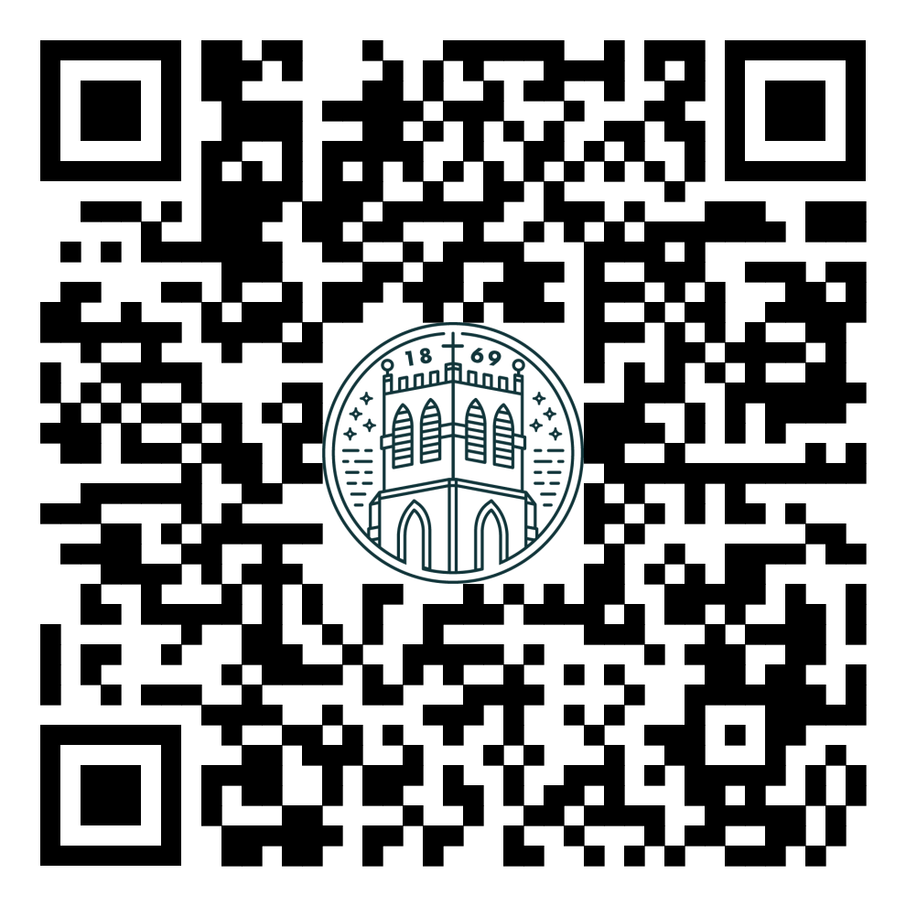
THE OFFERTORY
The people’s offerings are collected to support the ongoing work and ministry of our community. To give electronically, please use the QR code.

OFFERTORY HYMN 9 | Not Here for High and Holy Things

Please stand as you are able.
THE DOXOLOGY Renew 82

Praise God, from whom all blessings flow;
Praise Him, all creatures here below;
Praise Him above, ye heavenly host;
Praise Father, Son, and Holy Ghost.
Amen.

THE HOLY EUCHARIST Eucharistic Prayer A, BCP, p. 361
Celebrant The Lord be with you.
People And also with you.
Celebrant Lift up your hearts.
People We lift them to the Lord.
Celebrant Let us give thanks to the Lord our God.
People It is right to give God thanks and praise.

The Celebrant continues
It is right, and a good and joyful thing, always and everywhere to give thanks to you, Father Almighty, Creator of heaven and earth…

…Therefore we praise you, joining our voices with Angels and Archangels and with all the company of heaven, who for ever sing this hymn to proclaim the glory of your Name:

THE SANCTUS - S128
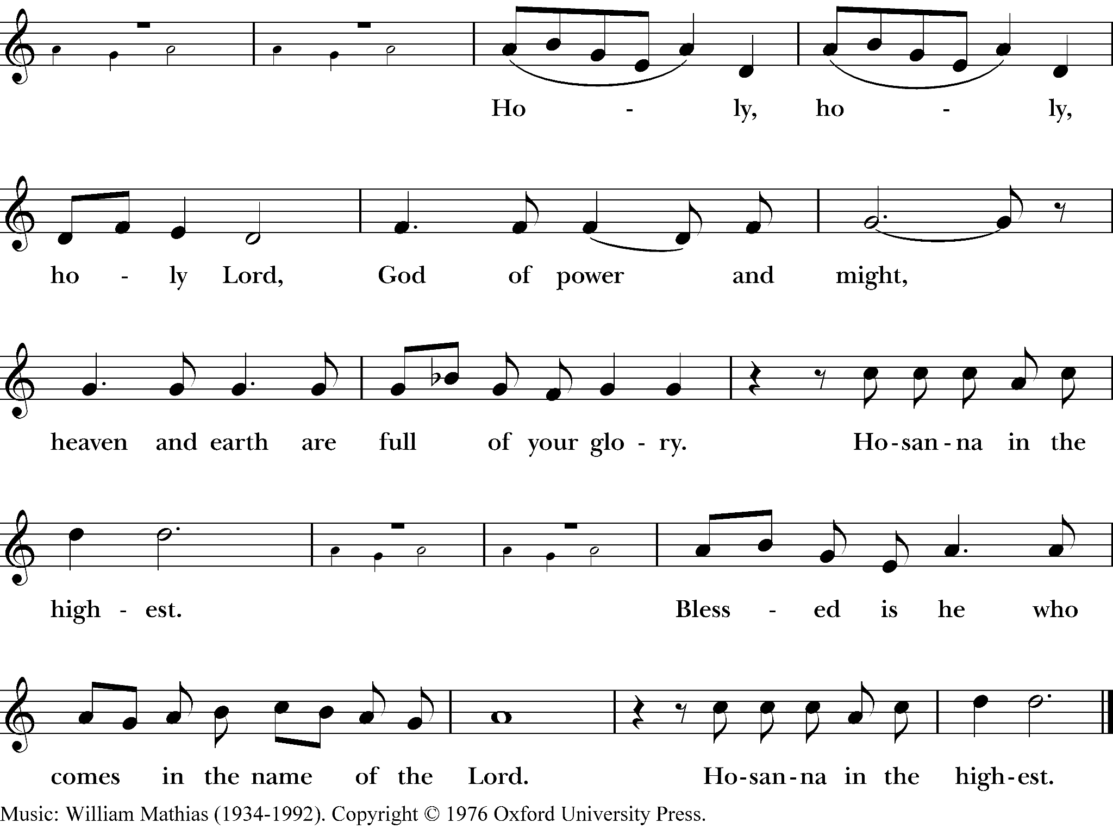

The people stand or kneel. The Celebrant continues
Holy and gracious Father: In your infinite love you made us for yourself, and, when we had fallen into sin and become subject to evil and death, you, in your mercy, sent Jesus Christ, your only and eternal Son, to share our human nature, to live and die as one of us, to reconcile us to you, the God and Father of all. He stretched out his arms upon the cross, and offered himself, in obedience to your will, a perfect sacrifice for the whole world.
On the night he was handed over to suffering and death, our Lord Jesus Christ took bread; and when he had given thanks to you, he broke it, and gave it to his disciples, and said, "Take, eat: This is my Body, which is given for you. Do this for the remembrance of me."
After supper he took the cup of wine; and when he had given thanks, he gave it to them, and said, "Drink this, all of you: This is my Blood of the new Covenant, which is shed for you and for many for the forgiveness of sins. Whenever you drink it, do this for the remembrance of me."

Therefore we proclaim the mystery of faith:
Christ has died.
Christ is risen.
Christ will come again.
We celebrate the memorial of our redemption, O Father, in this sacrifice of praise and thanksgiving. Recalling his death, resurrection, and ascension, we offer you these gifts
Sanctify them by your Holy Spirit to be for your people the Body and Blood of your Son, the holy food and drink of new and unending life in him. Sanctify us also that we may faithfully receive this holy Sacrament, and serve you in unity, constancy, and peace; and at the last day bring us with all your saints into the joy of your eternal kingdom.
All this we ask through your Son Jesus Christ: By him, and with him, and in him, in the unity of the Holy Spirit all honor and glory is yours, Almighty Father, now and for ever. Amen.
THE GREAT AMEN

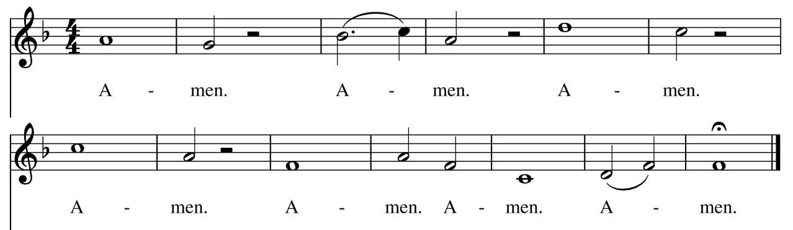

Celebrant And now, as our Savior Christ has taught us and in the language of our hearts, we are bold
to say
People
Our Father, who art in heaven,
hallowed be thy Name,
thy kingdom come,
thy will be done,
on earth as it is in heaven.
Give us this day our daily bread.
And forgive us our trespasses,
as we forgive those who trespass against us.
And lead us not into temptation,
but deliver us from evil.
For thine is the kingdom, and the power, and the glory,
for ever and ever. Amen.

Padre nuestro que estás en el cielo,
santificado sea tu nombre;
venga tu reino;
hágase tu voluntad
en la tierra como en el cielo.
Danos hoy nuestro pan de cada día.
Perdona nuestras ofensas,
como también nosotros perdonamos
a los que nos ofenden.
No nos dejes caer en la tentación
y líbranos del mal.
Porque tuyo es el reino, el poder
y la gloria,
ahora y por siempre. Amén.

THE BREAKING AND SHARING OF THE BREAD & WINE

Celebrant Alleluia. Christ our Passover is sacrificed for us;
People Therefore let us keep the feast. Alleluia.

FRACTION ANTHEM | Seed, Scattered and Sown
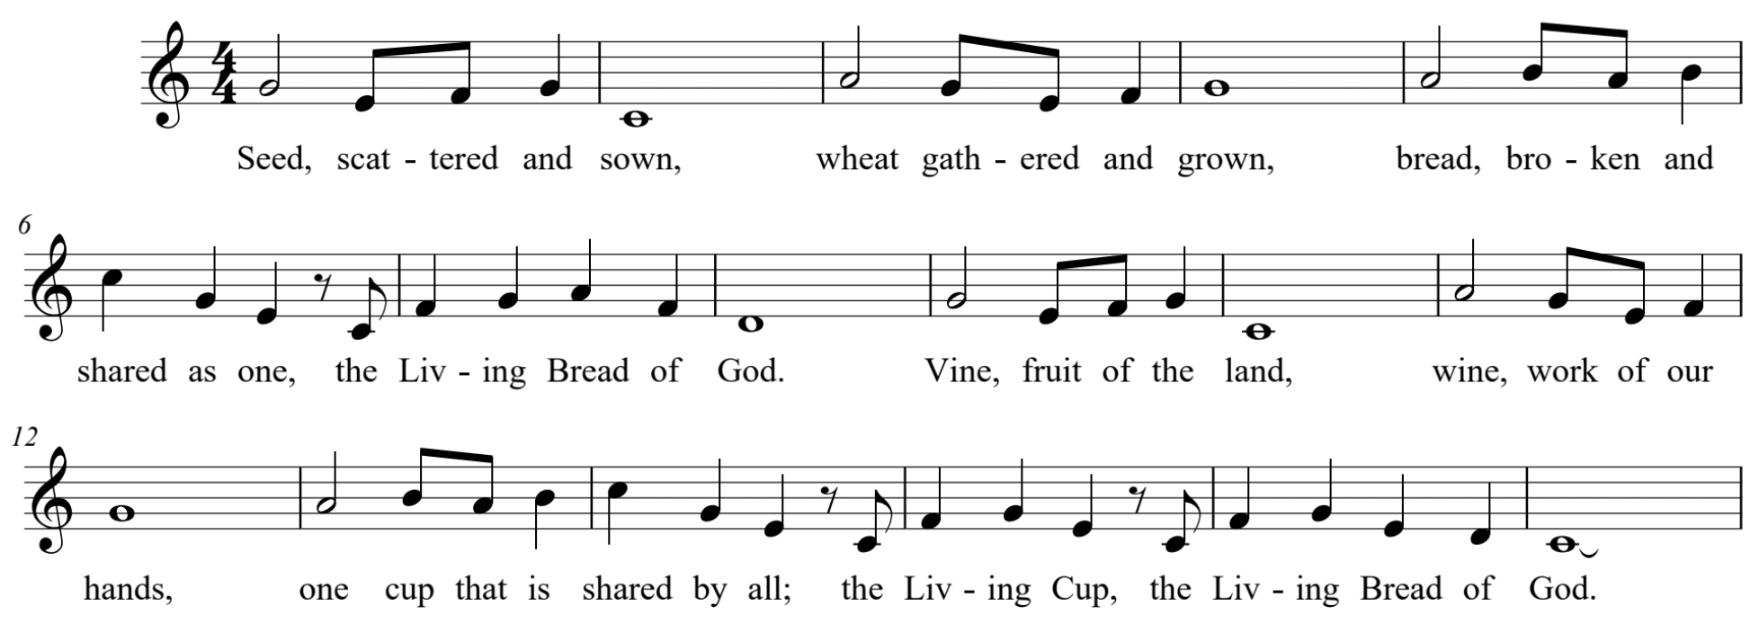

THE INVITATION
Celebrant The Gifts of God for the People of God. Take them in remembrance that Christ
died for you, and feed on him in your hearts by faith, with thanksgiving.

All people are welcome at God’s table. You may drink from the chalice by guiding it to your lips or you may instinct (dip) the consecrated host in the chalice or simply consume the host. If you would like a gluten-free wafer you may ask for one or point to your hand with one finger. If you would like to receive a blessing, please cross your arms over your chest. If you would like communion brought to you, please let an usher know.

COMMUNION HYMN LEVAS 213 | Children of the Heavenly Father
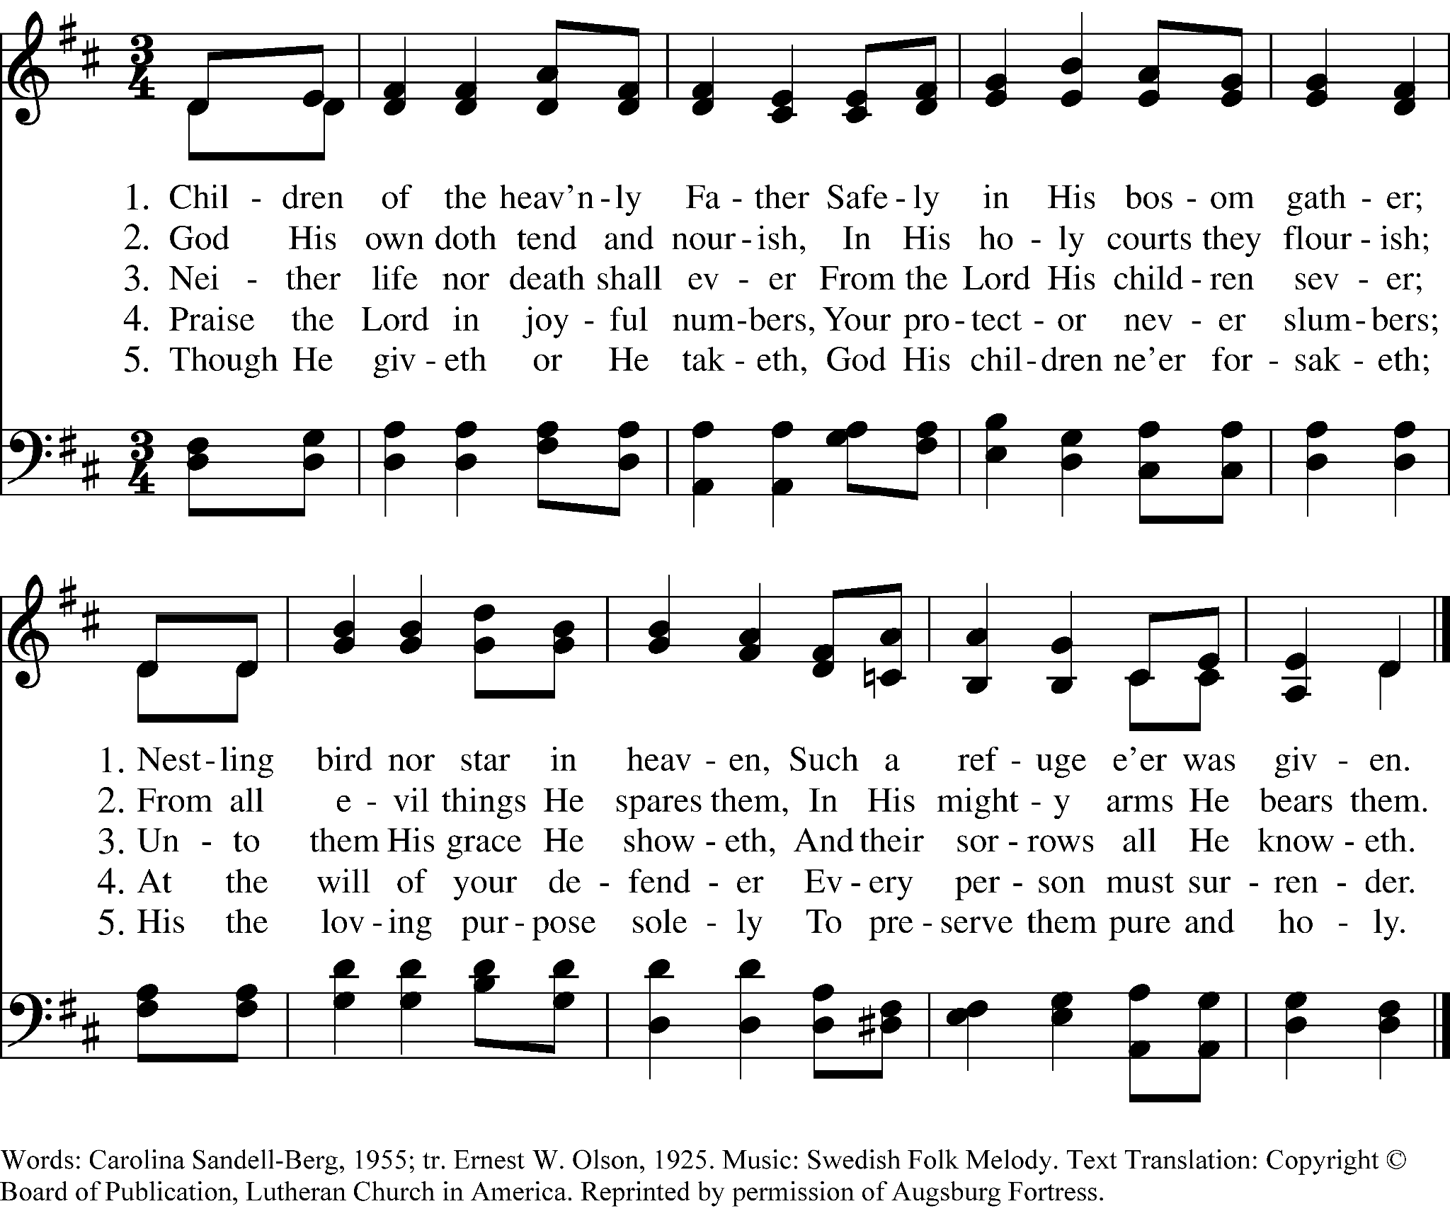

COMMUNION HYMN 711 | Seek Ye First

Please stand as you are able.
POST COMMUNION PRAYER BCP, p. 366
Celebrant
and people Almighty and everliving God, we thank you for feeding us with the
spiritual food of the most precious Body and Blood of your Son our Savior
Jesus Christ; and for assuring us in these holy mysteries that we are living
members of the Body of your Son, and heirs of your eternal kingdom. And
now, Father, send us out to do the work you have given us to do, to love
and serve you as faithful witnesses of Christ our Lord. To him, to you, and
to the Holy Spirit, be honor and glory, now and for ever. Amen.

THE BLESSING

CLOSING HYMN 533 | How Wondrous and Great Thy Works

THE DISMISSAL
Celebrant Go in peace to love and serve the Lord.
People Thanks be to God.

POSTLUDE

All rights reserved. Today’s music licensed under One License #A-731928 & CCLI License #1506679.

CALVARY PRAYER LIST

For those who have died:  Frank Weir  Long-term care & homebound:  Frances Johnson  Mary Poirier  Joe & Dee Turnus  Deogracia C. Perez  Discernment & wisdom:  Diane Weir  Rector Search Committee Members  Randy Fritz  Barbara Kayton  Sandy Kibby  Tom Palaima  Erika Rankin  Brianna Reyna  LaDonna Love - Vestry Rep  Terry Stringer - Vestry Rep  Kate Hurst - Sr. Warden | For those celebrating  birthdays & anniversaries:  Barbara Allbright  John Allbright  Lisa Chavez  Drew Krcmar  Pat Robson  Deena Thomas  Serving in the military:  Captain George Jackson Laughead  Major Will McMurrey  AFC Tiernan O’Rourke  SGT Daulton Robinson  Army Company 82  PFC Morgan H. Robinson  CW4 William "Billy" Black  CJ Calhoun | Healing & strength:  Ann Lunday  Barbara Kayton  Buck Bland  Gabriela Tuttrup  Harrison Hocker  John & Barbara Allbright  Julie Hodge  Kaden McInnes  Loyce Van Hoose  Laurie Boles  Neil McCasland  Kay Wesson  Tobin Bortner  Ben Everett  Dan Chamberlain  Clyde Howell  John and Megan Brown  Ted Schaefer  Nancy Jensen-Case  Byron Rentfro  Olivia Powell  Cheryl Green  Chris Trejo

COMING UP AT CALVARY

Backpack Drive for CASA | Donations Due July 31
Help support local children by donating a new backpack for CASA. Please bring donations to the Parish Hall by July 31. CASA will distribute the backpacks to children in need. Thank you for helping make a difference.
A Call to Feed the Hungry | Sunday, August 2
On Sunday, August 2, congregations across the Diocese of Texas will join together to help address hunger in our communities. Please bring non-perishable food donations to the Parish Hall so we can share them with local food banks.
Newcomer Gathering | Sunday, August 2 at 11:30 AM
New to Calvary or looking to connect more deeply? Join us for a Newcomer Gathering in the Galilee Building after the 10:00 AM service. Lunch will be provided, and we look forward to meeting you. Please RSVP to Mother Amy at curate@cecbastrop.org.
Blessing of Backpacks & Ice Cream Social | Sunday, August 9
Students are invited to bring their backpacks for a special blessing as we begin the new school year. Afterward, enjoy ice cream and fellowship with the Calvary community.
Coffee and Conversation | Sundays after the 10:00 AM Service
Stay for coffee and conversation in the Parish Hall following the 10:00 AM service each Sunday this summer.

Altar Flowers Giving
Let beauty become prayer. Honor a loved one or offer thanksgiving through flowers placed on the altar. Dedications may be included.
Scan the QR code to participate.

